[Array 15 (2022) 100197](https://doi.org/10.1016/j.array.2022.100197)

|  |  |  |
| --- | --- | --- |
|  |  |  |
|  | Contents lists available at ScienceDirect |  |
| Array |
| journal homepage: [www.sciencedirect.com/journal/array](https://www.sciencedirect.com/journal/array) |

Research on multi-factory combination optimization based on DOSTAR☆ Sen Chena,*, Jian Wanga, Manting Yana, Chuntao Yangb, Huihui Hana   
a *Computer Integrated Manufacturing System Research Center, College of Electronics and Information Engineering, Tongji University, No.4800 Cao’an Road, Shanghai, 201804, China*   
b *Global R&D Platform, Qingdao Economic & Technology Development Zone Haier Water-Heater Co., Ltd., Qingdao, 266101, China*

|  |  |
| --- | --- |
| A R T I C L E I N F O | A B S T R A C T |
| *Keywords:*  Combinatorial optimization Knowledge discovery  Reinforcement learning  AHP  Domain ontology  Six-tuple  Ternary data fusion  CPS | With the development of industrial big data, it has become an important research direction to use combinatorial optimization to coordinate multi-objective problems in complex manufacturing scenarios with multiple factories. At present, most of the multi-objective problems are decomposed into single-objective solutions. However, it is difficult to resolve the contradiction between multiple goals. There are many participants in multi-objective problems and complex data types, so there is no suitable research method at present. Based on big data, this paper integrates various aspects of supply chain management of multiple factories, and proposes a DOSTAR combined model. On the one hand, it conducts knowledge discovery based on the fusion of human-cyber- physical ternary data, on the other hand, it conducts multi-objective optimization through knowledge struc-ture. Among them, the most important thing is to establish the six-tuple as the basic model. Then the space weight, time weight and decision weight are obtained through the weight sub-model. Finally, the improved reinforcement learning algorithm is used to extract relevant new knowledge and complete multi-objective co-ordination. This article takes the supply chain management of Haier water heaters as an example, using the above-mentioned combined model, and the experimental results show that the purpose of improving perfor-mance has been achieved. |

**Credit author statement**

Sen Chen: mainly responsible for modeling and algorithm debugging of combinatorial optimization. Jian Wang: PhD supervisor, generally guiding the article. Manting Yan: mainly responsible for scene research, data collection and research of relevant literature. Chuntao Yang: mainly involved in scene research and sorting out business data. Huihui Han: participated in relevant literature research, data sorting and al-gorithm debugging.

**1. Introduction**

The coordination of multiple factories has been a hot topic in recent years. With the development of new technologies such as artificial in-telligence, the rapid changes in the market environment and the diver-sification of user needs. The multi-factory manufacturing environment becomes more and more complex, and relevant intelligent decision- making requires more and more data. Among them, the importance of

human as data sources has become increasingly obvious. The fusion of human-machine-physical ternary data [1] provides a solid foundation for knowledge discovery. Domain ontology is used to associate big data, then extract knowledge from it, and build a corresponding combination model. Finally, correct decisions through knowledge management and optimization could be made easily.

Different decision preferences and different levels of data belong to different goals. There are often conflicts between multiple goals. This paper constructs a DOSTAR model for combinatorial optimization (CO) to coordinate the benefits between multiple goals. In the DOSTAR model proposed in this paper, “DO” stands for domain ontology, “S" stands for spatial data, “T" stands for time data, “A" stands for decision data based on Analytic Hierarchy Process (AHP), and “R" stands for reinforcement learning (RL) algorithm. Ternary data fusion requires massive amounts of data as a basis. When solving some specific problems, part of the data is missing or the problem to be solved is too complicated. Therefore, in the calculation, these specific data are abstracted as weights, which can greatly optimize the calculation process and ensure the accuracy of the

☆ Jian Wang is the professor of Computer Integrated Manufacturing System Research Center. Sen Chen, Huihui Han and Manting Yan are the doctor students of CIMS Research Center. Chuntao Yang is working in Haier Water-Heater Co., Ltd.   
* Corresponding author.

*E-mail address:* [1910067@tongji.edu.cn](mailto:1910067@tongji.edu.cn) (S. Chen).

<https://doi.org/10.1016/j.array.2022.100197>   
[Received 27 February 2022; Received in revi](https://doi.org/10.1016/j.array.2022.100197)sed form 26 May 2022; Accepted 29 May 2022   
Available online 7 June 2022   
[2590-0056](http://creativecommons.org/licenses/by-nc-nd/4.0/)/© 2022 The Author(s). Published by Elsevier Inc. This is an open access article under the CC BY-NC-ND license (<http://creativecommons.org/licenses/by-nc-nd/4.0/>).

*S. Chen et al.*  *Array 15 (2022) 100197*

results. As one of the classic methods in the field of systems engineering, AHP is still widely used in recent years. It is because AHP will produce a series of relatively accurate decision weights in complex supply chain [2]. In addition, when calculating spatial and temporal data, this article imitates the human mindset and converts the specific values of spatio-temporal data into relative weight values. Therefore, spatiotemporal data can be easily incorporated into the final decision-making basis. These weighted data avoid the troubles caused by overly complex spe-cific data for decision-making. It should be explained that the temporal data represents the time point at which the process business occurs, but it is mainly used for the sequence of events in this study. Spatial data represents the business department, that is, the responsible subject of the event, to reflect the flow of business processes between different departments. The line chart with spatiotemporal data is used to visualize multiple event processes and facilitate the comparison before and after optimization.

Knowledge is the foundation of combinatorial optimization. The process of knowledge discovery is consistent with the combinatorial optimization model. There are many methods of knowledge discovery at present, among which the main keywords are data mining. In literature [3], a framework with multiple modules is proposed for knowledge discovery in the processing process. This article also uses a multi-module framework to study knowledge discovery. The premise of accurate reasoning is that the data meets certain specifications, which requires the form of knowledge expression to be more rigorous, such as extending from triples to six-tuples. Reinforcement learning is an intelligent al-gorithm that is more suitable for this scenario. This paper proposes an improved reinforcement learning algorithm to calculate and derive the associated knowledge in the complex manufacturing environment. It provides an associative knowledge discovery method that integrates multi-source spatiotemporal data and multiple sub-models.

In summary, based on the fusion of human-machine-physical ternary data, this paper proposes the DOSTAR method for combinatorial opti-mization. The purpose of this method is to model practical problems in complex manufacturing networks. The following content will focus on these points.

**2. Related work**

The purpose of this study is to improve the efficiency of quality traceability of water heaters. Business scenarios have the characteristics of multiple data sources, multiple decision makers, multiple spatial and temporal constraints, and strong correlation between data. Therefore, data fusion, decision weights based on AHP, spatiotemporal data, ontology and domain knowledge need to be studied separately. There-fore, relevant research also focuses on these topics.

*2.1. Combinatorial optimization*

There are many studies on combinatorial optimization. Generally, the multi-objective optimization problem is transformed into sub- objectives of multi-level or multi-stage, and solved relatively sepa-rately. Then the subsets are combined in a certain way to achieve the goal of optimization. In order to better support the proposed combina-tion model, this paper will analyze the literatures of other researchers from the aspects of group decision-making, knowledge discovery, rein-forcement learning, graph computing, production scheduling, and service-oriented manufacturing.

The literature proposes a combinatorial optimization model for group decision-making [4]. Each expert is assigned a weighting coeffi-cient, which makes it easy to adjust the differences between the experts’ knowledge and experience. In the literature [5], non-dominated sorting genetic algorithm (NSGA-II) is used to realize multi-objective combi-natorial optimization in MATLAB. Literature [6] and literature [7] are both researches that combine combinatorial optimization and knowl-edge discovery. Literature [6] proposes a multi-level combinatorial

2

*S. Chen et al.*  *Array 15 (2022) 100197*

compound methods. In literature [18], an advanced supply chain risk assessment model based on order of magnitude AHP (OM-AHP) was developed to compare the tangible and intangible factors that affect supply chain risk. An illustrative example is given to demonstrate the effectiveness of this assessment model. The evaluation method of machining process scheme based on AHP-GREY correlation analysis is proposed in the literature [19]. Analytic hierarchy process (AHP) is used to analyze the factors that affect the quality of the machining process plan, and the correlation degree is calculated by correlation coefficient and combination weight. Finally, the quality of the process plan is determined according to the correlation degree of the plan.

*2.4. Time and space governance*

As mentioned earlier, the spatiotemporal data governance studied in this article is mainly to convert specific spatiotemporal data into weight values. At present, the mainstream time alignment methods mainly include interpolation extrapolation, least square method, Taylor expansion method, etc. In the aspect of space governance, the origin of coordinates is not unified, and the common methods include Kalman filtering [20] and least square method [21]. In addition, there are sys-tematic errors for different descriptions of the same object. Since the benchmark of each description object is different, the results may also have errors. The commonly used methods include least squares, maximum likelihood and so on. In addition, spatiotemporal data governance is inseparable from data mining. A spatiotemporal data mining method based on ontology semantics is proposed in the literature [22]. Through the spatial data analysis method based on event-event and event-place, the information is mined from two aspects of space and time.

*2.5. Knowledge discovery*

Knowledge discovery is the process and method of extracting knowledge from massive amounts of big data. Within the scope of this article, knowledge discovery is closely related to three concepts: data mining, knowledge representation and reinforcement learning.

1) Data mining

As mentioned earlier, ternary data fusion provides a solid foundation for data mining and knowledge discovery. In literature [23], many data mining methods have been used to extract knowledge from solutions generated during multi-objective optimization. These methods are (i) sequential pattern mining, (ii) clustering-based classification trees, (iii) hybrid learning, and (iv) flexible pattern mining. Each method uses a unique learning strategy to generate explicit knowledge in the form of patterns, decision rules and unsupervised rules. In literature [24], data mining and knowledge discovery are carried out together in order to solve complex problems in intelligent production.

2) Knowledge representation

The representation forms of knowledge include Resource Description Framework (RDF), ontology, and knowledge graphs. Most of their data forms are triples or variants of triples. In literature [25], it is proposed a multi-agent algorithm able to automatically discover relevant regular-ities (knowledge) in a given dataset. Each agent operates independently by performing a Markovian random walk on a weighted graph repre-sentation. In literature [26], it is proposed a principled knowledge-based model in the form of a computational ontology. The literature [27] proposes a knowledge discovery method based on knowledge graph, which integrates heterogeneous data by introducing knowledge graph.

3) Reinforcement learning

3

*S. Chen et al.*  *Array 15 (2022) 100197*

into time and space weight values; and these weight values are stored in the form of the adjacency matrix. The fourth step is to form the six-tuple, which is to integrate the results of the second and third steps to form a six-tuple data set. The fifth step is the improved reinforcement learning algorithm, which converts the six-tuple into a weighted graph; then the weighted graph is chess boarded; therefore, the reinforcement learning algorithm can run smoothly. The sixth step is the result calculated from the fifth step. This result is a subgraph of the weighted graph of the previous six-tuple. At the same time, it is also a streamlined solution to a specific problem; it shows that associative knowledge is discovered. The above is shown in Fig. 1.

*3.2. Domain ontology sub-model*

The domain ontology model in this article is mainly established based on factors such as domain knowledge, expert experience, and data relationships. There are many places to study in complex manufacturing environment. This article is mainly based on the analysis of the actual situation of the complex manufacturing environment of Haier water heaters.

The main work content of the operation of the entire water heater

manufacturing environment includes: systematic planning, quality assurance and coordination meetings. Systematic planning is divided into single factory scheduling, multi factory scheduling, multi-vendor planning, and multi-D&S (delivery and sales) planning. The sched-uling of a single factory mainly refers to the annual plan. In addition, there are also a rolling 13-day production plan (T+13), a production and delivery plan for the next day (T+1), and a supply plan for one day in advance (T- 1). Multi factory scheduling needs to consider the distance between the delivery point and the shipping factory, which is strongly related to the cost and efficiency of transportation, and it is often considered to hand the order to the factory near the delivery point for production. In terms of quality assurance, after the after-sales service outlets receive feedback from users, they need to conduct quality tracing and determine the most suitable maintenance plan. Therefore, we also need to consider regional issues here, that is, considering spatiotemporal data and its weight data. Coordination meeting is an important mani-festation of human data in the entire model. The participants in the coordination meeting are senior experts from important factories, sales companies and after-sales service departments. They will discuss various uncertain factors in order to make correct decisions on specific issues.

There are many methods for constructing ontology models, most of

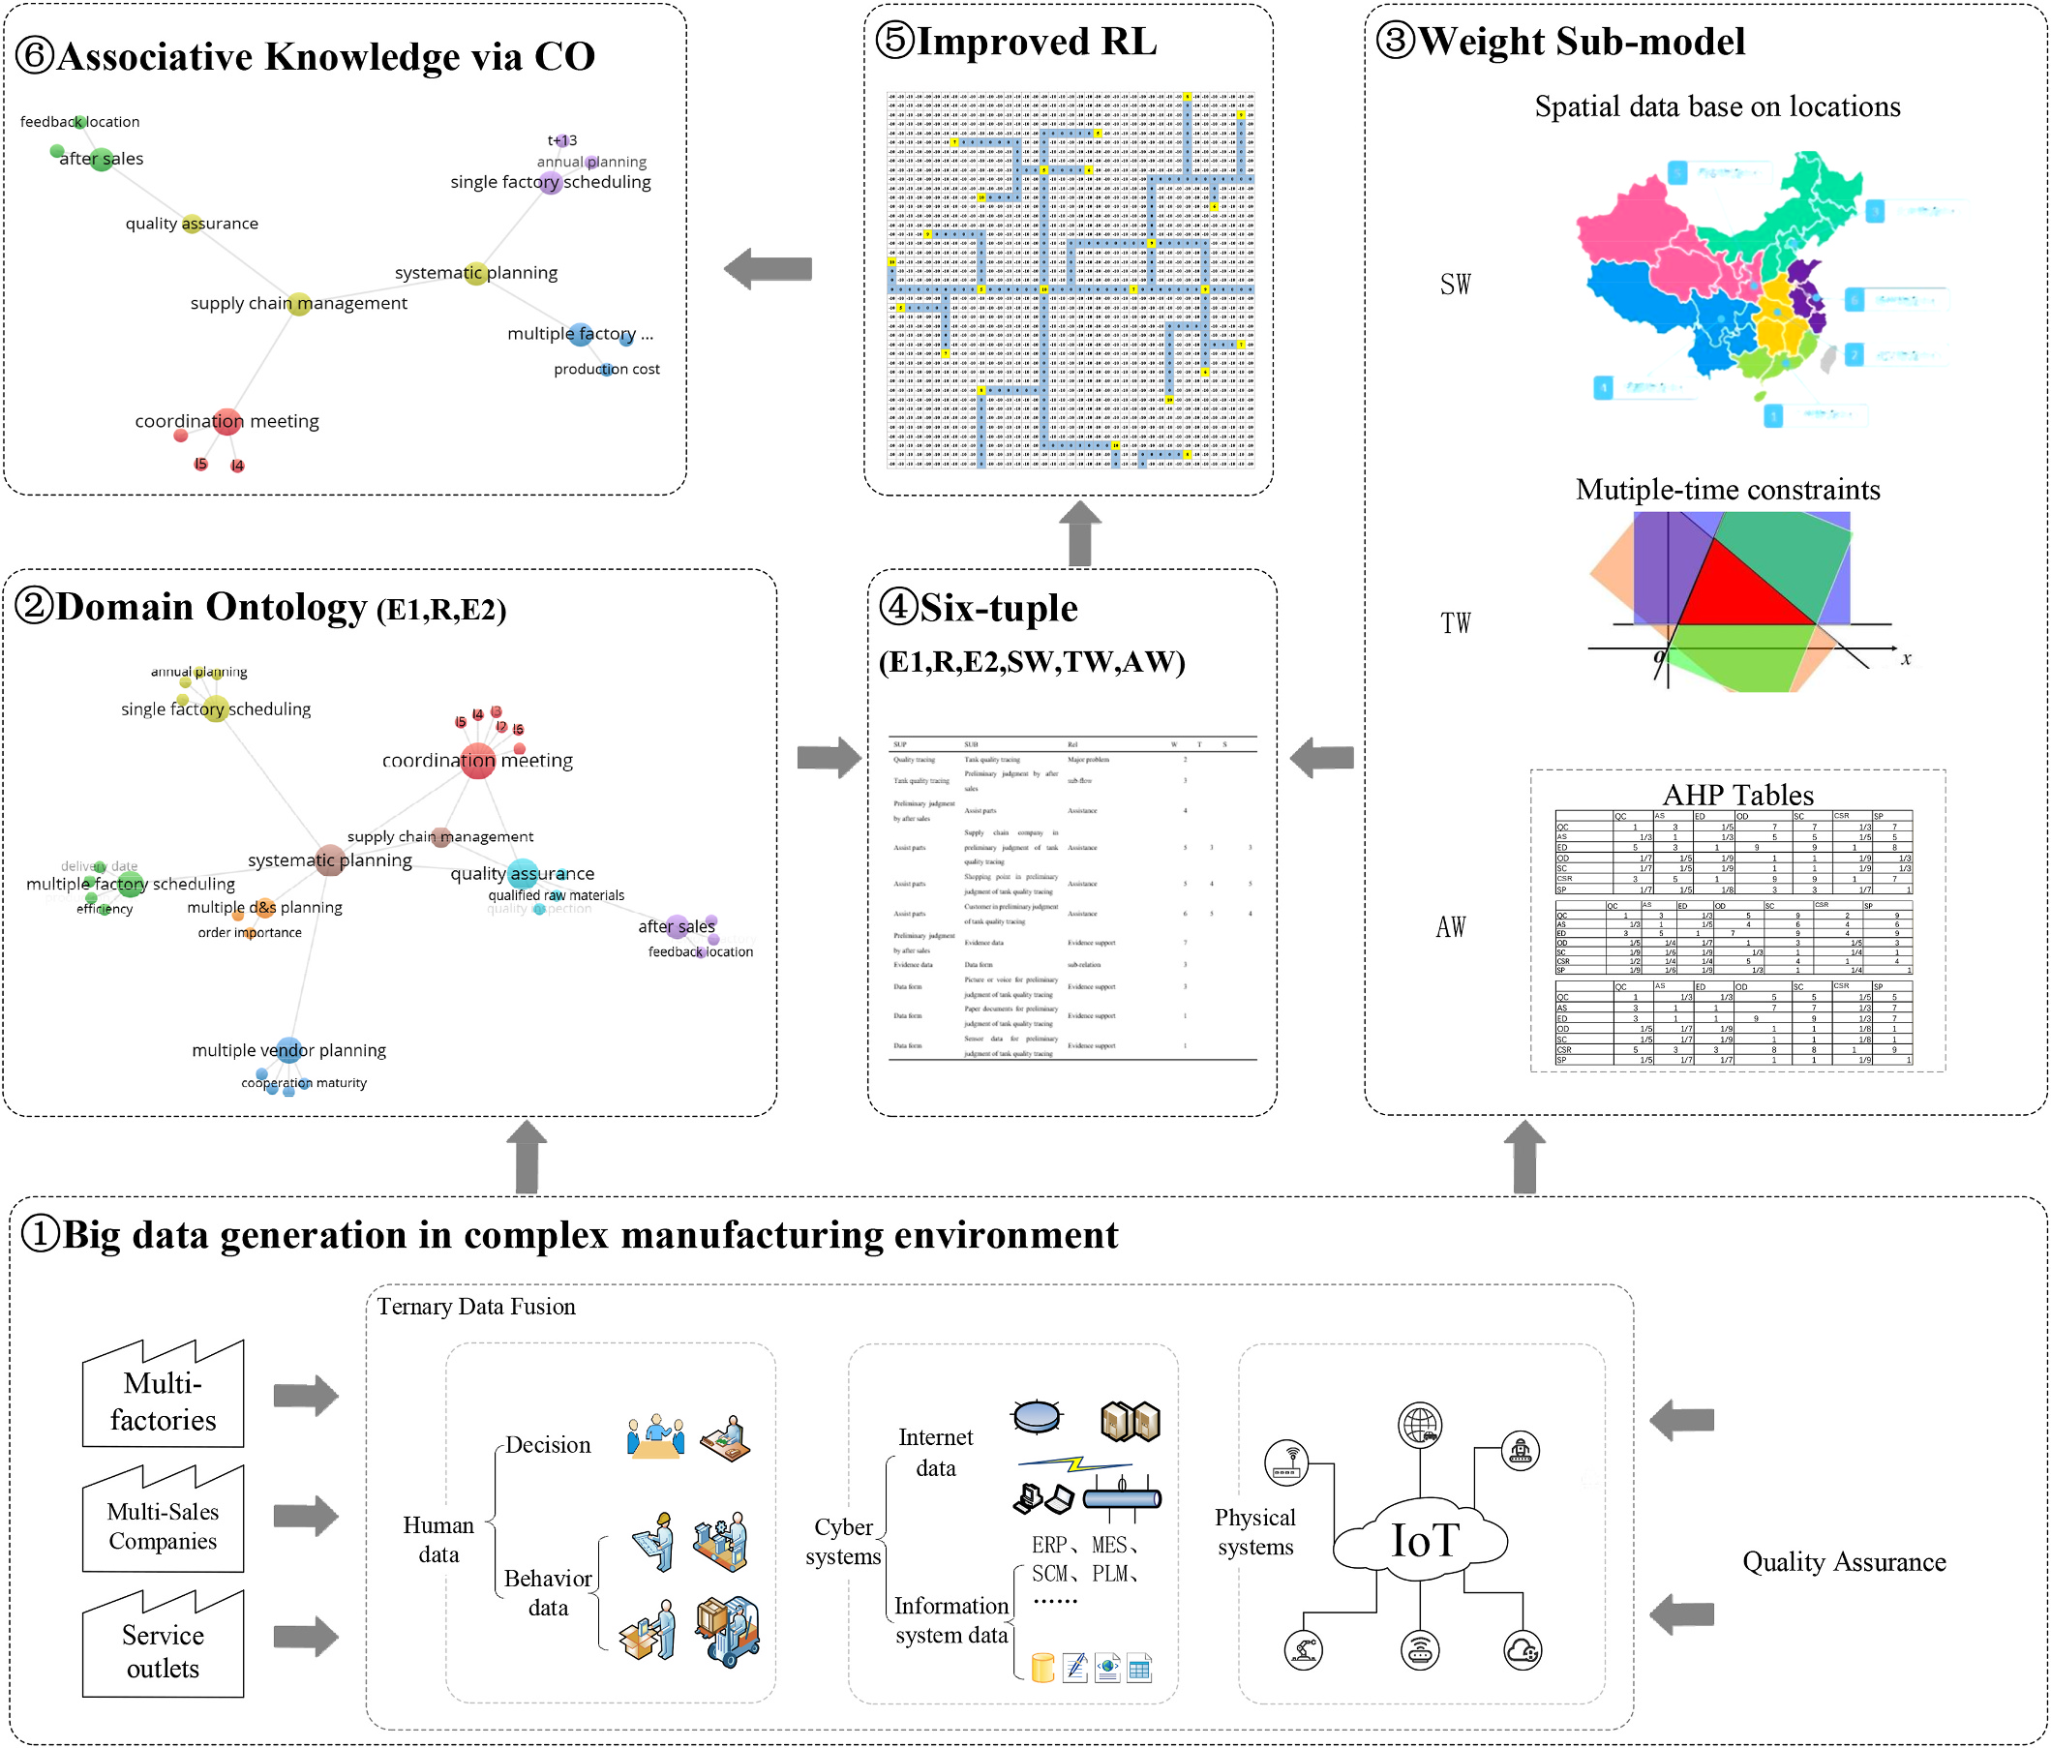

**Fig. 1.** The overall framework of associative knowledge discovery base on DOSTAR.

4

|  |  |  |
| --- | --- | --- |
| *S. Chen et al.* | *V*(*s*) = {11*,* 12*,* 13*,* 14*,* 15*,* 16} | *Array 15 (2022) 100197* |
| which are based on text mining. This article believes that decision- making structure, work flow, management specifications and encyclo-pedia can all be used as the basis for ontology construction. Domain ontology is an important step of this research, but the method of con-structing ontology is not the focus. Therefore, it will not go into too much detail here. | (3) |
| *SW* = {1*,* 2*,* 3*,* 4*,* 5*,* 6*,* 7*,* 8*,* 9} | (4) |
| *V*(*t*) = {11*,* 12*,* 13*,* 14*,* 15*,* 16} | (5) |
| *TW* = {1*,* 2*,* 3*,* 4*,* 5*,* 6*,* 7*,* 8*,* 9} | (6) |

*3.3. wt sub-model*

Weight refers to the degree of importance of a certain factor or in-dicator relative to a certain thing. Different levels of importance should be represented by different values. The weight value is a relative value, which mainly indicates the order of the importance of different factors or indicators.

1) AHP

Decision weights are often calculated using the AHP method. The construction of domain ontology and reinforcement learning is based on the top-level data fusion framework here.

Since the reward matrix only needs to be transformed by the weight value of the decision factor, there is no need to compare the solutions. Therefore, the AHP model in this paper is limited to the criterion level, but not the scheme level. The specific modeling is as follows:   
 In the first step, in order to integrate human data from multiple perspectives, this study adopts the decision preferences of factory di-rector, QA director and Sales director throughout the traceability pro-cess, which are defined as follows:

*A* = *(aij)* represents the factory expert’s decision matrix; *B* = *(bij)* represents the decision matrix of QA director; *C* = *(cij)* represents the decision matrix of Sales director.

In the reward matrix of reinforcement learning, these decision values need to be input, and different subsets of the matrix are selected ac-cording to the attributes of the six-tuples of different nodes, which are defined as follows:

*Rsub* =

In the second step, decision preferences are transformed into values ⎧⎨⎩  
 *aij,*

*bij,*

*cij,*   
 *sub* ∈ { *factory*

*sub* ∈ {*quality*}

*sub* ∈ { *after*  *sales* }   
 exp *ert* }   
 (1)

in the reward matrix through data reduction. It is defined as follows:

*R(subi)* is for the values of decision preference at children nodes “*subi*”   
*R*′*(subi)* is for the values of decision preference at children nodes “*subi*” after data reduction.

After many adjustments, the following formula is most suitable for integrating decision preferences into the reward matrix:

*R*′(*subi*) = *ROUNDUP*(*R*(*subi*) * *C,* 0) (2)

C is a constant here, and its value should be determined by trial and error. According to the setting of the reward matrix in this research, *R’(subi)*∈*{1,2,3,4,5,6,7,8,9,10}*. And according to repeated calculations, it comes *R(subi)*∈*(0.01, 0.5)*. After many trials, the value of C here is selected as 20.

2) Time and space governance

Spatiotemporal data has a lot of specific data, and in this study, in order to better integrate multiple models, they are transformed into adjacency matrix of weighted graph. It is defined as follows:

5

*S. Chen et al.*  *Array 15 (2022) 100197*

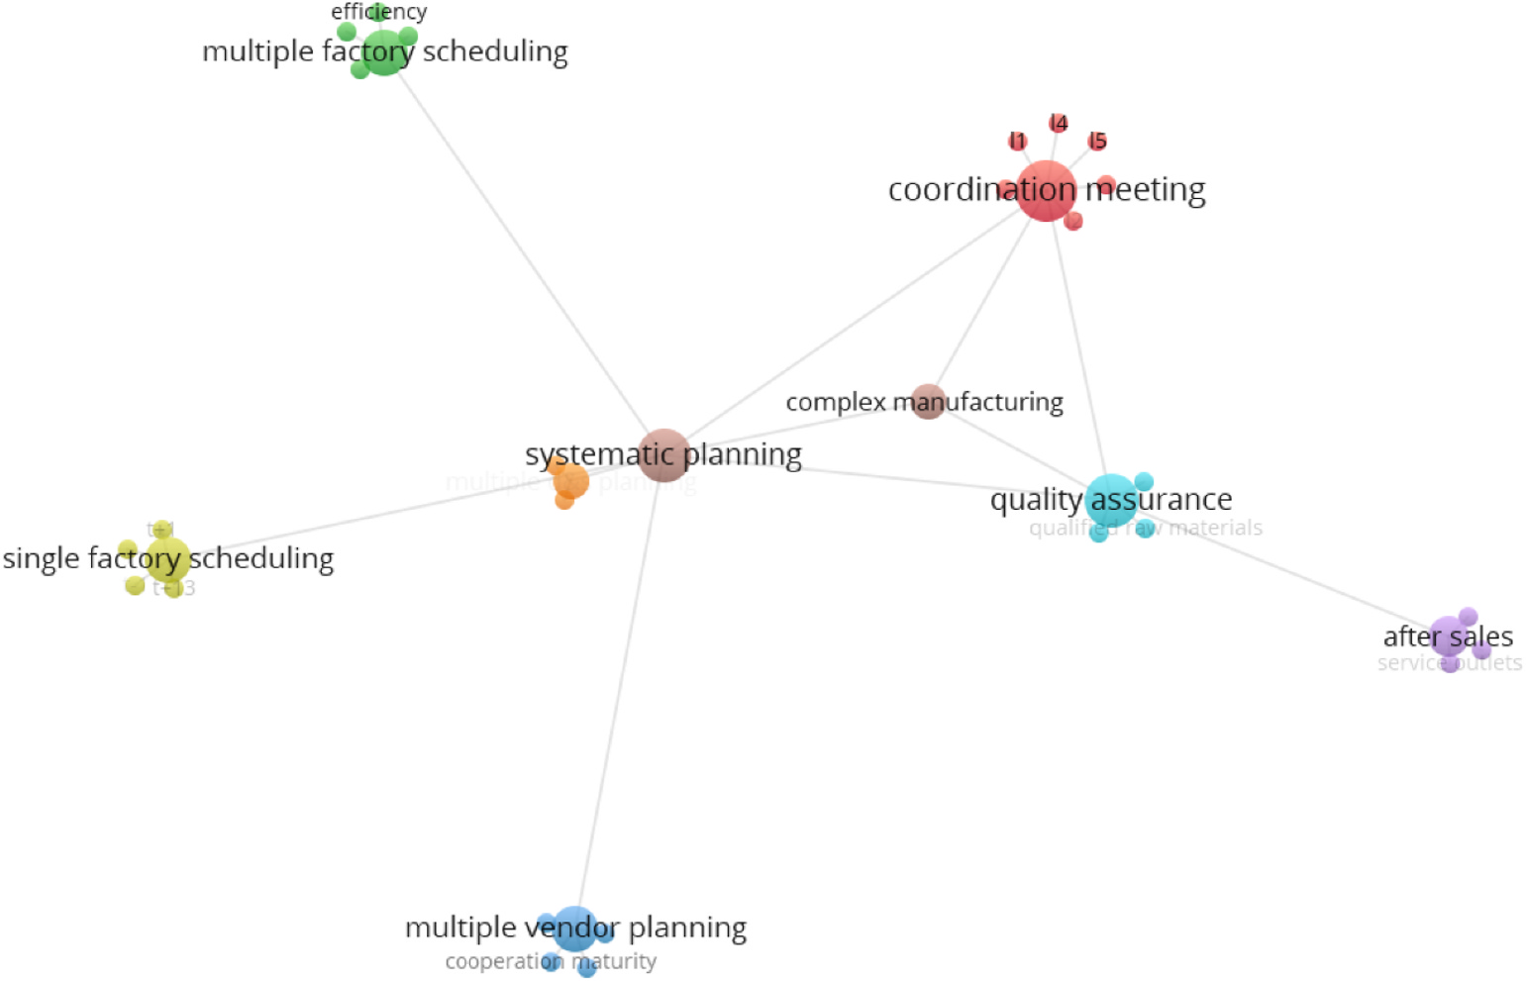

**Fig. 2.** Domain ontology for complex manufacturing environment of water heater.

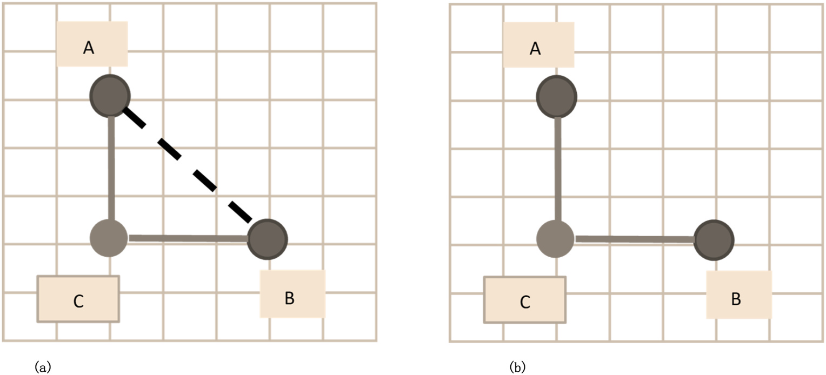

**Fig. 3.** (a) Adding right angle for the notes of ontologies**. (b)** Removing the original segment of notes.

the nodes and path are transformed into matrix or a kind of chessboard. Step 4, the calculation of the reinforcement learning algorithm on the chessboard.

The formula for Bellman equation of Q function is as follows:

|  |  |  |  |  |
| --- | --- | --- | --- | --- |
| *Qπ*(*s, a*) = | ∑*Pa ss*′ | [ *Ra ss*′ + *γ* | ∑*Qπ*(*s*′*, a*′) ] | (8) |

Where.

“*π*" stands for policy,   
“*γ*" represents the state value function, “*Q*" stands for action value function,   
“*P*" stands for state transition probability, “*R*" stands for reward,   
“*s*" stands for state, and   
“*a*" stands for action.

6

*S. Chen et al.*  *Array 15 (2022) 100197*

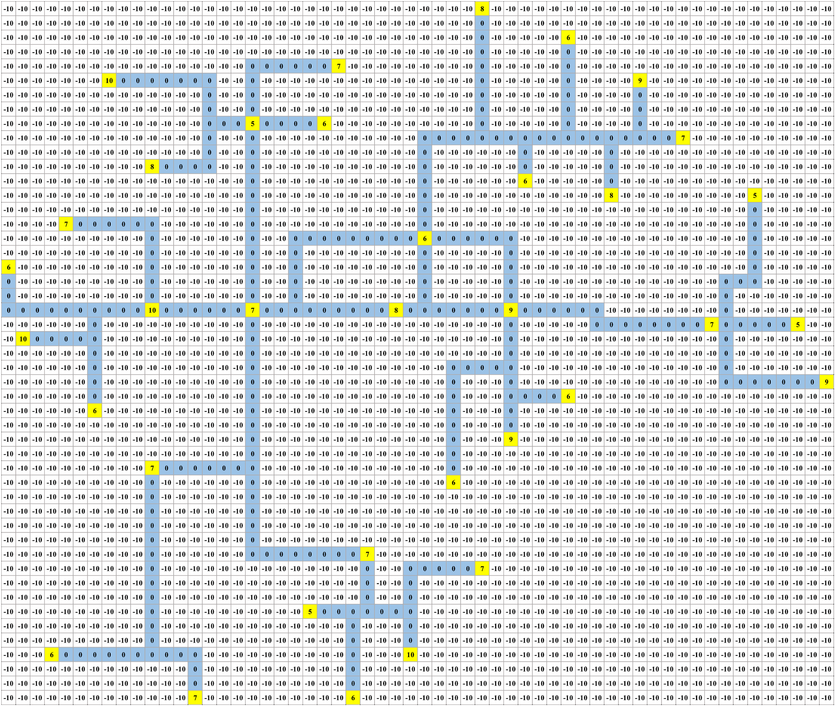

**Fig. 4.** Reward matrix in chessboard.

reinforcement learning from going around too much meaninglessly, it is needed to set a pioneering ratio (such as 30%), that is, the policies in Q- table are adopted in 70% of cases, but there is a 30% probability that the agent is randomly selected an action to have a try. In addition, for the purpose of preventing the agent from missing important “passing points”, this model limits the minimum value of the cumulative dis-counted return (reward), such as 80 or even higher. That is, the total value of the cumulative discounted return of the model must be greater than 80, otherwise it is not considered to find a suitable result. But the calculation steps increase rapidly when the number of this constraint is larger. After more than 5000 steps of training (due to the existence of random values, sometimes tens of thousands of steps, and more complex cases requiring even millions or more), the optimal cumulative dis-counted return (reward) can be found for one kind of tracing.

**4. Case study**

In this part, it takes specific events in the complex manufacturing environment of Haier water heaters as an example to verify the above model. Orders for “A" products need to be produced in advance and shipped to the sales company “*l2*” (location “*l5*′′). Although these orders are in the annual plan of a certain factory (location “*l4*′′), the delivery date has been advanced. At the same time, product A received some fault

7

*S. Chen et al.*  *Array 15 (2022) 100197*

**Table 2**   
A six-tuple when the order is advanced and the quality needs to be improved.

|  |  |  |  |  |  |  |  |  |  |
| --- | --- | --- | --- | --- | --- | --- | --- | --- | --- |
| E1 | | | R | | E2 | | SW | TW | AW |
| complex   manufacturing environment   management  complex   manufacturing environment   management  complex   manufacturing environment   management  Quality assurance | | | sub-level | | Quality  assurance | | 8 | 9 | 6 |
| sub-level | | Systematic Planning | | 8 | 7 | 6 |
| sub-level | | Coordination meeting | | 7 | 6 | 6 |
| influencing factors  sub-level | | After sales | | 6 | 7 | 6 |
| Systematic Planning | | | Single factory  scheduling  Multiple factory scheduling  Annual planning | | 7 | 9 | 8 |
| Systematic Planning | | | sub-level | | 7 | 9 | 7 |
| Single factory   scheduling  Single factory   scheduling  Multiple factory   scheduling  Multiple factory   scheduling  Coordination meeting | | | combination calculation  combination calculation  combination calculation  combination calculation  influencing factors  influencing factors  influencing factors  influencing factors  influencing factors | | 7 | 7 | 8 |
| T+13 | | 5 | 5 | 6 |
| Production cost | | 6 | 5 | 8 |
| Load vs  Capacity  L2 | | 8 | 5 | 6 |
| 9 | 6 | 6 |
| Coordination meeting | | | L4 | | 7 | 6 | 8 |
| Coordination meeting | | | L5 | | 9 | 6 | 8 |
| After sales | | | Feedback  location  Rework factory | | 7 | 6 | 8 |
| After sales | | | 5 | 9 | 5 |
| **Table 3**  The matrix of factory director’s decision. *CR*1 = 0.091.  QA AF1 AF2 SFS MFP CM_l2 | | | | | | | CM_l4 | | CM_l5 |
| QA  AF1  AF2  SFS  MFP  CM_l2 CM_l4 CM_l5 | 1  1/7  1/5  1/5  3  1/3  1/3  1/3 | 7  1  5  5  7  7  7  7 | 5  1/5  1  1  5  5  5  5 | 5  1/5 1  1  5  7  7  7 | 1/3  1/7  1/5  1/5  1  1  1  1 | 3  1/7  1/5  1/7  1  1  1  1 | 3  1/7  1/5  1/7  1  1  1  1 | | 3  1/7  1/5  1/7  1  1  1  1 |
| **Table 4**  The matrix of QA director’s decision. *CR*2 = 0.0721.  QA AF1 AF2 SFS MFP CM_l2 | | | | | | | CM_l4 | | CM_l5 |
| QA  AF1  AF2  SFS  MFP  CM_l2 CM_l4 CM_l5 | 1  1/2  1/2  1/7  3  1/5  1/2  1/7 | 2  1  1/2 1/5 2  1/4 3  1/6 | 2  2  1  1  5  1/5  1  1/7 | 7  5  1  1  7  3  3  1/3 | 1/3  1/2  1/5  1/7  1  1/3  1/3  1/9 | 5  4  5  1/3  3  1  3  1/3 | 2  1/3  1  1/3  3  1/3  1  1/5 | | 7  6  7  3  9  3  5  1 |

consistency of decision-making results, it is necessary to ensure that CR is less than 0.1. In addition, there are certain conflicts between multiple decision-making preferences. In order to further optimize this situation, different decision preferences need to be weighted to obtain a result that satisfies every decision maker. After the negotiation of the decision makers, the integrated weights of the three decision makers are

8

|  |  |  |  |  |  |
| --- | --- | --- | --- | --- | --- |
| *S. Chen et al.* |  |  |  | traceability. | *Array 15 (2022) 100197* |
| **Table 7**  Weight results. |
|  |
| Factory director | QA director | Sales director | Final weight | **5. Conclusion** |  |

|  |  |  |  |  |
| --- | --- | --- | --- | --- |
| QA  AF1  AF2  SFS  MFP  CM_l2 CM_l4 CM_l5 | 24.22%  1.84%  4.16%  3.87%  20.42%  15.16%  15.16%  15.16% | 19.54%  13.49%  10.59%  4.26%  30.55%  5.75%  13.73%  2.10% | 23.88%  10.80%  10.80%  2.43%  22.45%  3.98%  21.67%  3.98% | 24.09%  9.42%  9.52%  3.72%  27.14%  7.20%  15.40%  3.49% |

abilities of interpretability and fusing cross-domain and cross-layer data are quite innovative and remarkable for real business use. If the same data is used, other algorithms cannot perform calculations directly, and some data preprocessing work is also required. In addition, single al-gorithms can only solve sub problems; they cannot solve all the prob-lems corresponding to the algorithms proposed in this article.

In this section, first six-tuple is used to integrate multi-source data and perform the governance of spatiotemporal data. Then, the decision weights are determined by AHP. Then, through reinforcement learning algorithms, calculations are performed on a “chessboard” based on the ontology of the business scenario and fused with the calculation results of other sub-models; associative knowledge is discovered for decision- making. Through data verification, the calculation results of this model improve the overall work efficiency of water heater quality

Based on the multi-factory case of Haier electric water heater, this paper constructs an DOSTAR fusion model for associative knowledge discovery. This fusion model is divided into four parts: Weight sub- model, domain ontology, six-tuple and improved reinforcement learning. This research integrates various types of big data from multiple dimensions, multiple perspectives, cross-regions, and across time hori-zons throughout the whole process. These data include structured, semi- structured and unstructured data. These data are connected through AHP and domain ontology. The inclusiveness of these connections is very good. In particular, this study fuses human data through the AHP sub-model. The improved reinforcement learning sub-model shows that this research uses artificial intelligence algorithms for associative knowledge discovery. Finally, through the case study, it is obviously that this method can effectively optimize the entire manufacturing network to achieve the purpose of reducing costs and increasing efficiency. It provides innovative ideas for solving related problems.

Due to the relatively short time, there is no time to debug the multi- agent reinforcement learning model. I believe this will greatly shorten the calculation time of the reinforcement learning model. In addition, follow-up research work will further expand the data. More detailed and large knowledge discovery is expected.

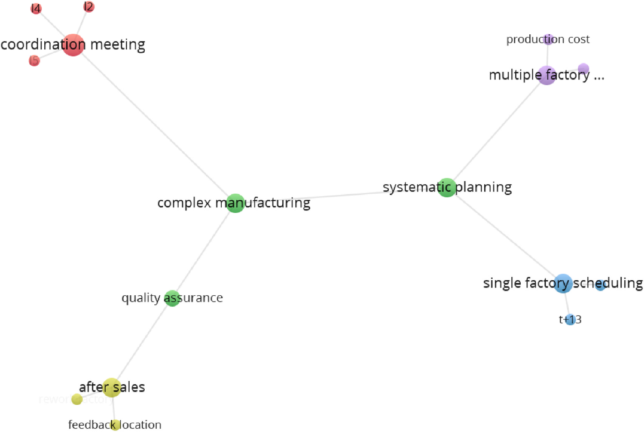

**Fig. 5.** The subgraph representing the associative knowledge.

**Table 8**   
Comparison of the effects of different algorithms.

|  |  |  |  |  |
| --- | --- | --- | --- | --- |
| Method comparison | Advantage | Disadvantage | Interpretability | Cross-domain and cross layer |
| Deterministic planning model | Fast and accurate | Can’t solve the problem of  uncertainty  Unable to calculate environmental feedback  Prone to fitting problems and  dimensional disasters  Initial modeling takes time | Yes | No |
| Ontology | Suitable for the fusion of ontology and relationship at the level of natural language  Can handle massive amounts of data | Yes | No |
| Machine learning | No | No |
| New method in this article (reinforcement learning + ontology) | Can handle massive amounts of data and interpretability | Yes | Yes |

9

*S. Chen et al.*  *Array 15 (2022) 100197*

**Declaration of competing interest**

The authors declared that they have no conflicts of interest to this work. We declare that we do not have any commercial or associative interest that represents a conflict of interest in connection with the work submitted.

**Acknowledgement**

This work was supported by the National Science and Technology Innovation 2030 Next-Generation Artificial Intelligence Major Project, Data-Driven Tripartite Collaborative Decision-Making and Optimiza-tion, under Grant 2018AAA0101800.

**References**

[1] Chen S, Wang J, Li H, Wang Z, Liu F, Li S. Top-down human-cyber-physical data fusion based on reinforcement learning. IEEE Access 2020;8:134233–45. [https://](https://doi.org/10.1109/ACCESS.2020.3011254) [doi.org/10.1109/ACCESS.2020.3011254](https://doi.org/10.1109/ACCESS.2020.3011254).

[2] [Chand P, Thakkar JJ, Ghosh KK. Analysi](https://doi.org/10.1109/ACCESS.2020.3011254)s of supply chain complexity drivers for Indian mining equipment manufacturing companies combining SAP-LAP and AHP.

Resour Pol 2018;59:389–410. <https://doi.org/10.1016/j.resourpol.2018.08.011>. [3] Amouzgar K, Bandaru S, Ande[rsson T, Ng AHC. A framework for simulation-bas](https://doi.org/10.1016/j.resourpol.2018.08.011)ed multi-objective optimization and knowledge discovery of machining process. Int J Adv Manuf Technol 2018;98(9–12):2469–86. [https://doi.org/10.1007/s00170-](https://doi.org/10.1007/s00170-018-2360-8) [018-2360-8](https://doi.org/10.1007/s00170-018-2360-8).

[4] [Korsemov D](https://doi.org/10.1007/s00170-018-2360-8), Borissova D, Mustakerov I. Combinatorial optimization model for group decision-making. Cybern Inf Technol 2018;18(2):65–73. [https://doi.org/](https://doi.org/10.2478/cait-2018-0028) [10.2478/cait-2018-0028](https://doi.org/10.2478/cait-2018-0028).

[5] [Martinez S, Gonzalez C,](https://doi.org/10.2478/cait-2018-0028) Hospitaler A, Albero V. Sustainability assessment of constructive solutions for urban Spain: a multi-objective combinatorial optimization problem. Sustainability 2019;11(3). [https://doi.org/10.3390/](https://doi.org/10.3390/su11030839) [su11030839](https://doi.org/10.3390/su11030839).

[6] [Sitek P, Wik](https://doi.org/10.3390/su11030839)arek J. A multi-level approach to ubiquitous modeling and solving constraints in combinatorial optimization problems in production and distribution. Appl Intell 2018;48(5):1344–67. <https://doi.org/10.1007/s10489-017-1107-9>.

[7] Elorza A, Hernando L, Mendiburu [A, Lozano JA. Estimating attraction basin size](https://doi.org/10.1007/s10489-017-1107-9)s of combinatorial optimization problems. Prog Artif Intell 2018;7(4):369–84. [https://](https://doi.org/10.1007/s13748-018-0156-6) [doi.org/10.1007/s13748-018-0156-6](https://doi.org/10.1007/s13748-018-0156-6).

[8] [Vesselinova N, Steinert R, Perez-Ram](https://doi.org/10.1007/s13748-018-0156-6)irez DF, Boman M. Learning combinatorial optimization on graphs: a survey with applications to networking. IEEE Access 2020;8:120388–416. <https://doi.org/10.1109/ACCESS.2020.3004964>.

[9] Lu H, Zhou R, Cheng [S, Shi Y. Multi-center variable-scale search algo](https://doi.org/10.1109/ACCESS.2020.3004964)rithm for combinatorial optimization problems with the multimodal property. Appl Soft Comput 2019;84. <https://doi.org/10.1016/j.asoc.2019.105726>.

[10] Chalupa D, Hawic[k KA. GraphCombEx: a software tool for exp](https://doi.org/10.1016/j.asoc.2019.105726)loration of combinatorial optimisation properties of large graphs. Soft Comput 2019;23(14): 5715–24. <https://doi.org/10.1007/s00500-018-3230-x>.

[11] Chaabani [A, Bechikh S, Ben Said L. A co-evolutionary h](https://doi.org/10.1007/s00500-018-3230-x)ybrid decomposition-based algorithm for bi-level combinatorial optimization problems. Soft Comput 2020;24 (10):7211–29. <https://doi.org/10.1007/s00500-019-04337-0>.

[12] Jiang T, Zhang [C. Application of grey wolf optimization for s](https://doi.org/10.1007/s00500-019-04337-0)olving combinatorial problems: job shop and flexible job shop scheduling cases. IEEE Access 2018;6: 26231–40. <https://doi.org/10.1109/ACCESS.2018.2833552>.

[13] Zhao S, Zh[ang Q, Peng Z, Lu X. Personalized manufacturin](https://doi.org/10.1109/ACCESS.2018.2833552)g service composition recommendation: combining combinatorial optimization and collaborative

10